Grand Concours

French Club

Paris Subway Stations

The first homeroom to have all answers right.

*(Admin building counts as homeroom, teachers without homeroom can join Admin's/library team)*

(Questions could be split among students/teacher/group of students)

French breakfast (French Club ice tea + fresh baguettes and fresh croissants delivered 2nd period by French Club members)

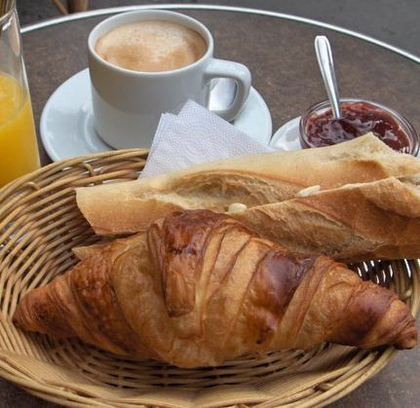

1. Why is Mr. Granillo's room "Châtelet"?
2. Why is Mrs. Bejarano's room "Pasteur"?
3. Why is the bookstore "Bourse"?
4. Why is Mr. Lansa's office "Champs-Elysées/Clémenceau"?
5. Why is the ISS room "Bastille"?
6. Why is PAC "Bercy""?
7. Why is the door to the counselors called "Cluny-La Sorbonne"?
8. Why is the administration "Hôtel de Ville"?
9. What subway station do you need to arrive at the Eiffel Tower? (the closest one)
10. What subway stations can you stop at to go to Le Louvre Museum (name two)?
11. What station do you need to stop to visit the Catacombes?
12. What is "Citroën", who has that stop and why?
13. What is the name of the island where NDP is, what is the only stop on that island?
14. Which RER line (RER ►suburb train that is bigger and faster than regular subway) do you need to go to Disneyland Paris? A, B, C, D, or E?
15. When was the Eiffel Tower built and for what occasion?
16. Which station is made of copper and considered one of the nicest ones in Paris? Which teacher has it?
17. What subway station do you need to go to and see the Roland Garros Grand Slam Tennis Tournament in June?
18. What was Le Louvre before being the largest museum in the world?
19. What was the name of Paris during Roman Occupation?
20. What is left of the Roman Empire in Paris (name two things you can still visit)?
21. If Julius Caesar had to take the subway to get a bath, where would he have stopped?
22. Name the café where Ernest Hemingway used to sit down and write The Sun Also Rises There?
23. Name the subway station to go to that café.
24. If Marie Antoinette had taken the subway to be guillotined… where would she have stopped?
25. What American Institution is nearby nowadays?